**Azar, The Unbreakable**

**Story**

Due to his long exposure to the Cube, his massive stature and his alien rocklike body morphed and evolved him into a perfect and powerful golem. He became the first line of defense in the catacombs they had created for the cubes protection.

**Health:** 2000

**Phase switch:** 50% health left.

**Damage:** See “Attack”

**Aesthetic**:

* Giant stone statue (Tech mixed with Stone)
* Has a massive core in his chest
* Pieces of stone float around him(*Optional*)

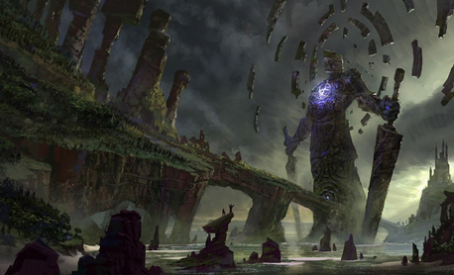

*(Art from Google)*

**Depth Mechanic:**

* Every now and then, the screen will shake and the player will move slower. Like an earthquake

**Boss Room:**



**Phase 1**

**Movement:**

* Disassembles and floats in a cloud of statue parts to the four sides of the room.

**Mechanic:**

* He shakes the screen as he walks

**Attacks:**

* **Attack 1**: Basic Attack
  + **Range:** Short
  + **Damage:** 50(per hit) 3 hit combo
  + **Effect:** Three hit combo and the final hit will knock the player around
* **Attack 2**: Ground Slam
  + **Range:** Short
  + **Damage:** 75(per hit)
  + **Effect:** Heavy knockback on attack
* **Attack 3**: Rock Wave
  + **Range:** Medium
  + **Damage:** 75(per hit)
  + **Effect:** Sends out a rock wave in a cone out in front of him
* **Attack 4**: Rock Throw
  + **Range:** Long
  + **Damage:** 150(per hit)
  + **Effect:** throws a massive rock at the player

**Weak Point:**

* Center of his chest.

**Phase 2**



^Updated boss room after he creates the walls.

* He pulls the walls in, Making the room smaller
* This makes it harder to avoid his attacks and creates a larger sense of urgency.

**Weapon:** Azar’s Will

**Type**: Assault rifle

**Magazine size:** Large

**Damage:** Moderate

**Effect:** Slows enemies by making tiny earthquakes around the player.